**HW4 - Generative Models**

**1. Model Architecture**

The implemented model follows the **Generative Adversarial Network (GAN)** framework, consisting of a **Generator (G)** and a **Discriminator (D)**. The architecture is as follows:

**Generator Architecture**

The **generator** transforms a latent vector **z** (sampled from a Gaussian distribution) into a realistic image through a series of **transposed convolutional layers**:

* **Input**: A 256-dimensional latent vector Z
* **Projection & Reshape**: 4×4×1024
* **Deconv 1**: 8×8×512 (ConvTranspose2d + BatchNorm + ReLU)
* **Deconv 2**: 16×16×256 (ConvTranspose2d + BatchNorm + ReLU)
* **Deconv 3**: 32×32×128 (ConvTranspose2d + BatchNorm + ReLU)
* **Deconv 4**: 64×64×3 (ConvTranspose2d + Tanh activation)
* **Output**: A 64×64×3 RGB image

The final activation function is **Tanh**, ensuring pixel values are scaled between -1 and 1.  
  
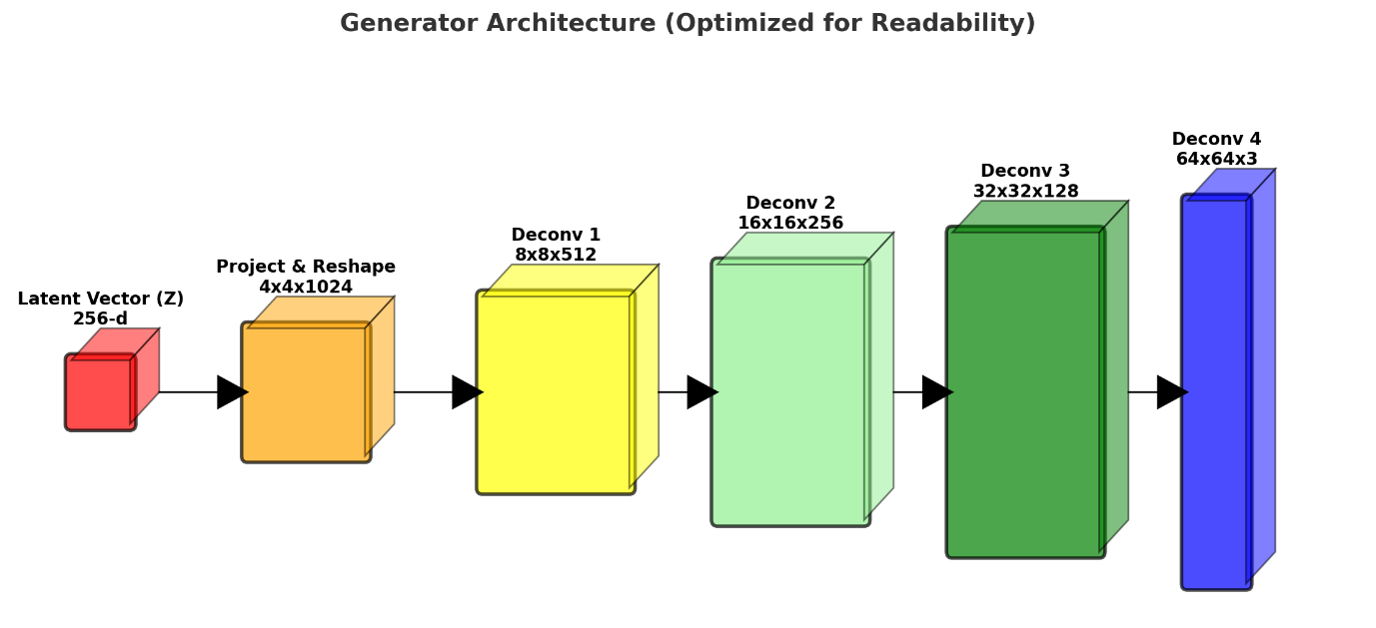

**Discriminator Architecture**

The **discriminator** is a convolutional neural network (CNN) that classifies whether an input image is **real** or **fake**:

* **Input**: 64×64×3 RGB image
* **Conv 1**: 32×32×64 (Conv2d + LeakyReLU)
* **Conv 2**: 16×16×128 (Conv2d + BatchNorm + LeakyReLU)
* **Conv 3**: 8×8×256 (Conv2d + BatchNorm + LeakyReLU)
* **Conv 4**: 4×4×512 (Conv2d + BatchNorm + LeakyReLU)
* **Conv 5**: 1×1×1 (Conv2d + Sigmoid)
* **Output**: A single value indicating the probability of the input being real or fake.

The activation function in the last layer is **Sigmoid**, which outputs a probability score.

**2. Training Procedure**

The GAN is trained using the **min-max adversarial loss**:



Each training step consists of:

1. **Discriminator Training**:
   * Given real images x, compute D(x) and maximize log(D(x)).
   * Given fake images G(z), compute D(G(z)) and log(1−D(G(z))).
2. **Generator Training**:
   * Generate fake images G(z).
   * Maximize log(D(G(z))), i.e., make the discriminator think generated images are real.

**3. Hyperparameters**

* **Latent Space Dimension**: z=256
* **Batch Size**: 64
* **Number of Channels**: 3 (RGB images)
* **Generator Feature Maps**: 64
* **Discriminator Feature Maps**: 64
* **Epochs**: 300
* **Learning Rate**: 0.0002
* **Adam Optimizer**:
  + β1=0.5
  + β2=0.999

**4. Optimization & Regularization**

* **Weight Initialization**:
  + Normal distribution with mean 0 and std 0.02 for convolutional layers.
  + BatchNorm layers initialized with mean 1 and std 0.02.
* **Leaky ReLU in Discriminator**: Slope = 0.2
* **Batch Normalization**: Applied to stabilize training.

**5. Implementation Details**

* **Dataset**: Images were preprocessed using **Resize (64x64),  
  CenterCrop, Normalize ([0.5, 0.5, 0.5])**.
* **Training Setup**: Implemented in **PyTorch**, utilizing CUDA when available.

**Discriminator Loss Analysis (Red Plot)**

* Initially, the **discriminator loss is relatively high**, which is expected because the discriminator is learning to differentiate between real and fake images.
* The loss **gradually decreases**, indicating that the discriminator is getting better at distinguishing real from fake samples.
* However, **sharp spikes** occur periodically, which suggests:
  + The generator temporarily improves and fools the discriminator.
  + The discriminator adapts quickly and corrects itself, leading to sudden loss increases.
* The overall **trend shows oscillations**, which is typical in GAN training, as the generator and discriminator compete.
* The **final loss values are quite low**, indicating that the discriminator has learned to identify fake samples efficiently.

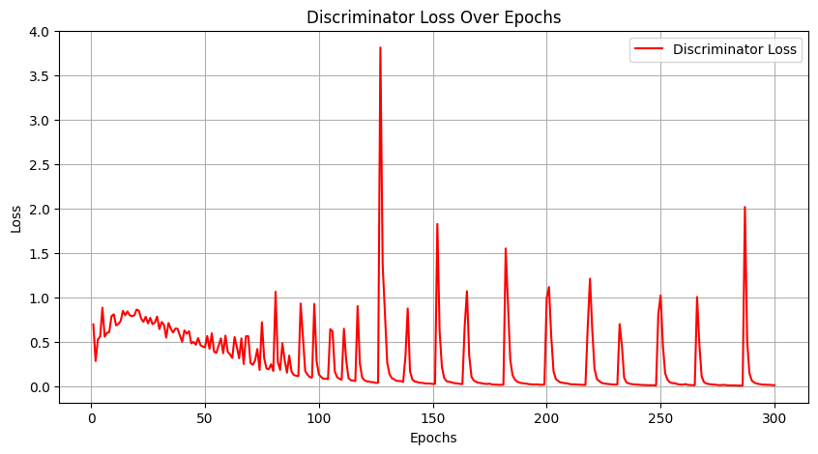

**Generator Loss Analysis (Blue Plot)**

* At the beginning, the **generator loss is extremely high (~13)**, indicating that the generator is producing very poor images.
* As training progresses, the **loss decreases but later begins to oscillate and increase**.
  + This suggests that the generator is struggling to fool the discriminator.
* Around **epoch 100 onwards**, periodic **sharp dips** appear, indicating:
  + Some iterations where the generator successfully fools the discriminator (lower loss).
  + The discriminator quickly adapts, pushing the generator loss back up.
* The overall **increasing trend after 100 epochs** suggests the **discriminator is overpowering the generator**, preventing it from improving significantly.

**Interpretation & Training Stability**

* The observed **instability** (loss fluctuations) is a common issue in GAN training due to the adversarial nature of the model.
* The **generator's increasing loss indicates that the discriminator might have become too strong**, making it difficult for the generator to produce realistic images.

**Summary of Attempts and Conclusions**

**1. Overview**

In this HW4, a Generative Adversarial Network (GAN) was trained on a dataset of flower images. The model was evaluated under two different settings of the **latent space dimension**: **100** and **256**. We were interested to assess the effect of latent space size on the quality, diversity, and realism of generated images.

**2. Comparison of Results**

**2.1 Latent Dimension = 100**

* **Epoch 20**: The generated images were blurry, lacking clear structures and well-defined colors.
* **Epoch 80**: Image quality improved significantly, with distinguishable floral patterns, although still containing some artifacts.
* **Epoch 100-160**: The generated flowers became sharper, with more vibrant colors and diversity.
* **Epoch 180-300**: The model captured fine textures, but some images still exhibited noticeable distortions. However, the overall quality and diversity of the flowers were satisfactory.

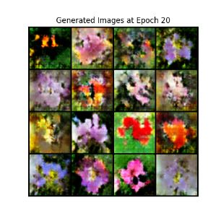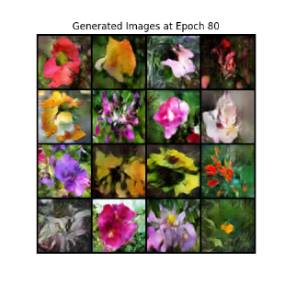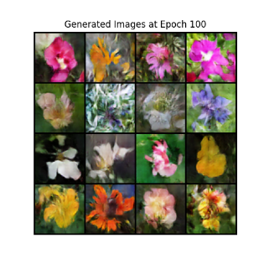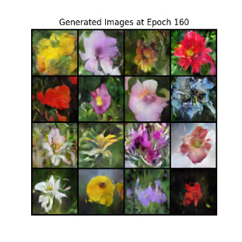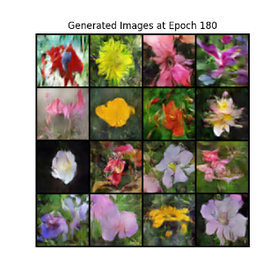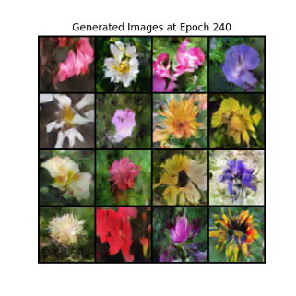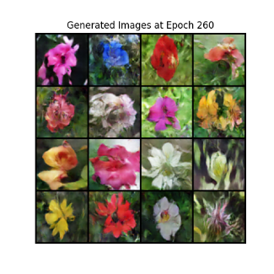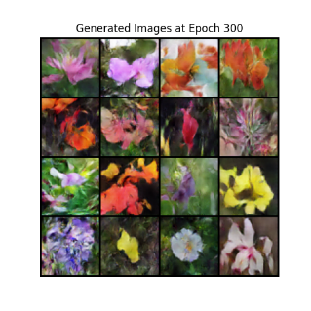

**Latent Space Interpolation:** The transition between different latent points was smooth, but some intermediate images displayed unnatural blending artifacts.

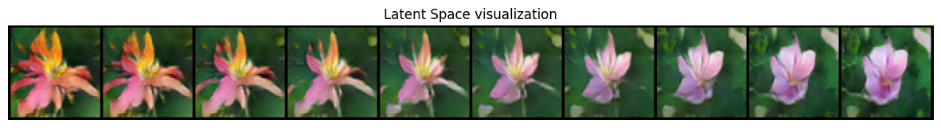

**2.2 Latent Dimension = 256**

* **Epoch 20**: Images were slightly more detailed than those from the latent dimension 100 experiment, but still blurry.
* **Epoch 80**: The generated flowers displayed more realistic textures, sharper edges, and better color blending.
* **Epoch 100-160**: Fine details, such as petal edges and vein structures, became visible. The colors appeared more natural and balanced.
* **Epoch 180-300**: The generated flowers showed significant improvement, with distinct species characteristics, higher color fidelity, and better spatial consistency.

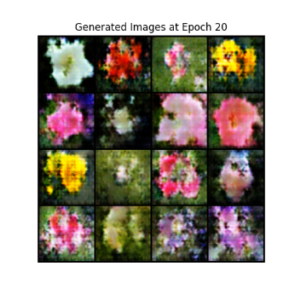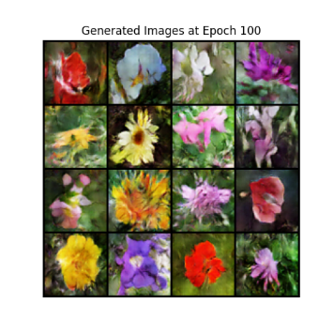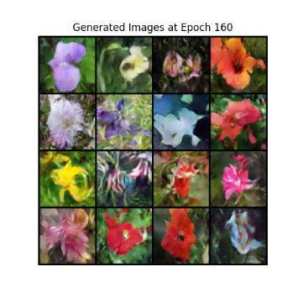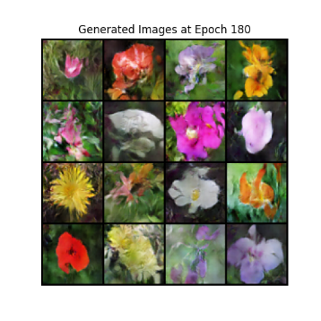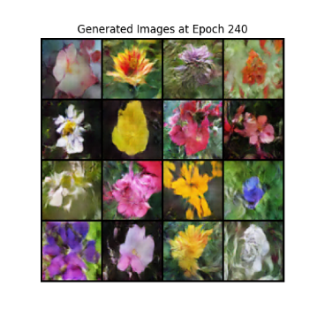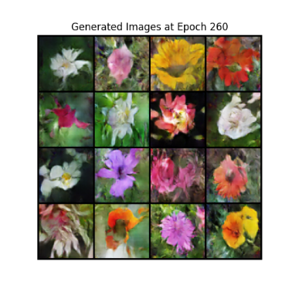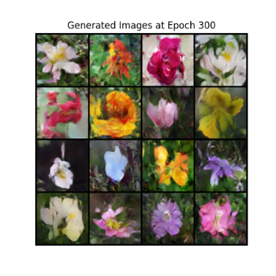

**Latent Space Interpolation:** The transition between different points in latent space was smoother, with fewer blending artifacts, indicating better representation of the learned features.

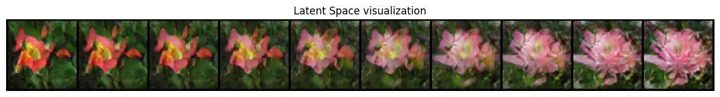

**3. Observations and Analysis**

1. **Higher Latent Space Dimension Improves Image Quality**
   * The images generated with **latent dim = 256** were more realistic, with richer textures and sharper details than those produced with **latent dim = 100**.
   * A larger latent space provides more expressive power for the generator, allowing it to capture fine-grained details better.
2. **Training Stability and Convergence**
   * The discriminator loss exhibited oscillations in both cases, indicating the adversarial nature of GAN training.
   * The generator loss, particularly in the **latent dim = 100** case, showed higher fluctuations, suggesting that it struggled more to generate realistic images.
   * The model with **latent dim = 256** converged more smoothly and exhibited better training stability.
3. **Mode Collapse and Diversity**
   * In both cases, **mode collapse was not evident**, meaning the generator was able to produce diverse floral images rather than a limited set of repeating patterns.
   * The diversity in generated images was higher with **latent dim = 256**, as it allowed for more variation in color and structure.
4. **Smoothness of Latent Space Interpolation**
   * The **latent dim = 256** model demonstrated a **smoother and more natural transition** between different points in latent space.
   * The **latent dim = 100** model had more abrupt changes and blending artifacts between latent points, suggesting that the representation capacity was more constrained.

**4. Challenges and Improvements**

**Challenges Encountered:**

* Some generated images still had visible artifacts, especially in early epochs.
* The discriminator learned faster than the generator at times, leading to suboptimal training dynamics.

**Potential Improvements:**

* **Use Progressive Growing of GANs (PGGAN):** This can improve fine-grained texture learning.
* **Spectral Normalization in Discriminator:** This helps stabilize training and prevents discriminator overpowering.
* **Adjust Learning Rate Scheduling:** Dynamic adjustment of learning rate based on convergence metrics could help stabilize training.
* **Experiment with Different Latent Space Sizes:** Trying values between 100 and 256 (e.g., 128, 192) may provide a good balance of expressiveness and training stability.

**5. Conclusion**

* **Larger latent space (256) led to more detailed and realistic images**, demonstrating its advantage in capturing fine features.
* **Training stability was slightly better with larger latent dimensions**, as it allowed for smoother generator updates.
* **Both models successfully captured floral patterns**, but the **256-dimensional latent space** provided a significant improvement in **sharpness, color richness, and diversity**.